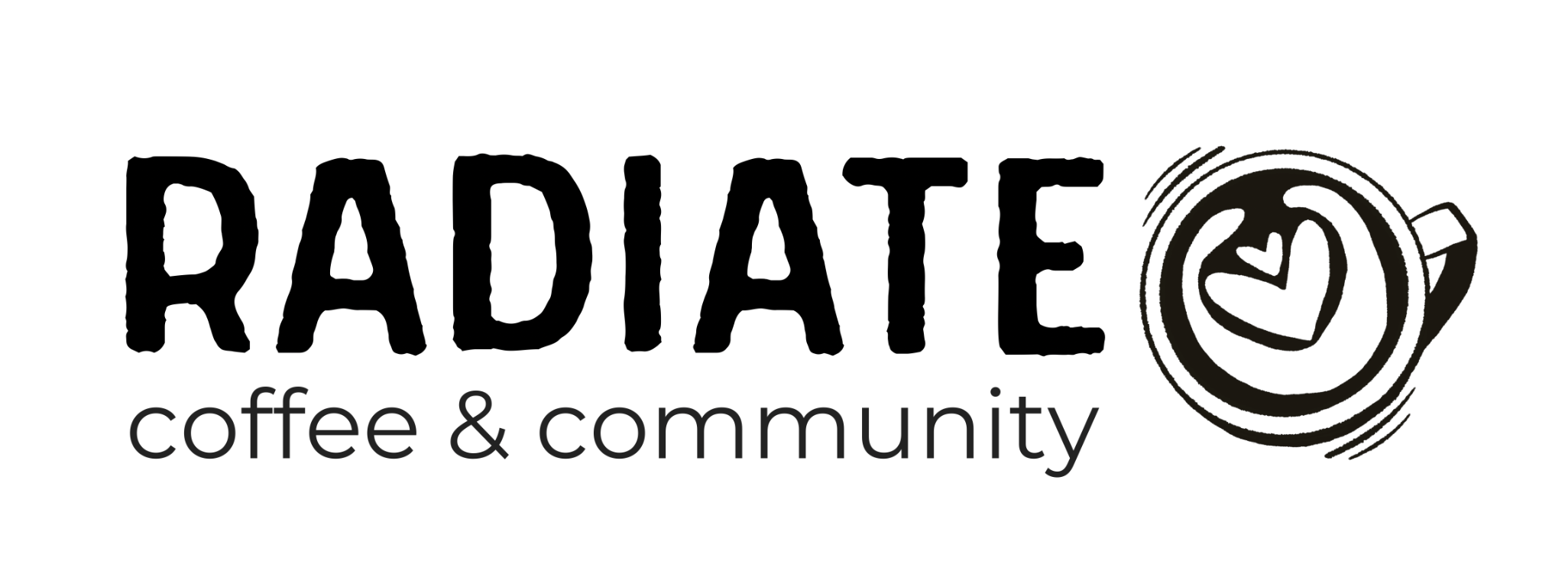

Location: 2311 SW 6th Ave, Suite C2, Camas, WA 98607
Questions: djwigen@radiatecommunity.com

Join the Radiate Coffee & Community Team. More Than Coffee. More Than a Job.
At Radiate Coffee & Community, we believe great coffee can bring people together. Our café is designed to be a welcoming gathering place where exceptional coffee, fresh bakery items, genuine hospitality, and meaningful relationships create lasting community.
We are committed to creating opportunities for people of all abilities, believing that everyone has unique gifts to contribute. Check us out at http://www.radiatecommunity.com

We're Looking for People Who:
- Enjoy serving others with kindness and respect
- Take pride in quality and attention to detail
- Are dependable and eager to learn

Whether you're an experienced barista or simply someone who loves serving others, we'd love to learn more about you

Are you interested?
Full Name:
Email Address:
Phone Number:
Tell us about your experience in the food or customer service industry (Attach a resume - Optional).

Why do you want to work at Radiate Coffee & Community?

Approximately how many hours per week are you looking to work:
Thank you for your interest!

